SONA COLLEGE OF ARTS AND SCIENCE –SALEM -5
CLASS : III – B.SC (MATHS) STAFF NAME: Mrs. B. Mythreyee
SUBJECT: C PROGRAMMING
UNIT-I
OVERVIEW OF C
1. HISTORY OF C:
- ALGOL (ALGOrithmic Language)
  - It is root of modern language.
  - Introduced in 1960.
  - It was the first computer language to use a block structure.
- BCPL (Basic Combined Programming Language)
- In 1967, Martin Richards developed a language called BCPL.
  - B:
    - In 1970, Ken Thompson created a language using many features of BCPL called C.
      - C:
        - C was evolved from ALGOL, BCPL and B by Dennis Ritchie at Bell Laboratories in 1972.
        - It is strongly associated with UNIX.
        - UNIX is one of the most popular network operating system.
          - ANSI C:
            - C language remains standard, in 1983, American National Standard Institute (ANSI) to define a standard for C.
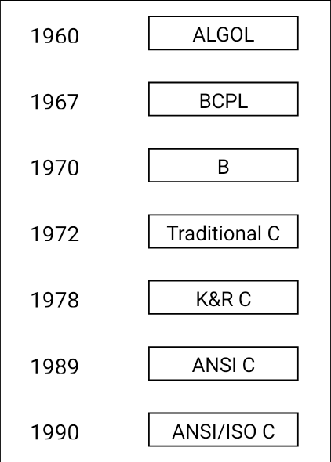

IMPORTANCE OF C:
- Incrementing popularity of C is probably due to its many desirable qualities.
- Robust Language
  - Rich set of built-in functions and operators used to write a complex program.
  - Programs written in C are efficient and fast.
  - Varity of data types and powerful operators.
  - Standard functions are available.
- Highly Portable
  - C programs written for one computer can be run on another with little of no Modification.
  - C program is basically a collection of functions that are supported by C library.
BASIC STRUCTURE OF C PROGRAMS:
- C Programs can be viewed as a group of building blocks called functions.
- Functions:
  - It is a subroutine that may include one or more statements designed to perform a specific task.
  - C programs contain one or more sections.
    - Documentation Section:
      - It consists of a set of comment lines giving the name of the program, author and other details.
        - Link Section:
          - Provides instructions to the compiler to link functions from the system library.
            - Definition Section:
              - Define all symbolic constants.
                - Global Declaration section
- Some variables that are used in more than one function such variables are called Global Variable and declared in the Global Declaration Section.
  - Main () function section
    - Every c program must have one main function. Section contains two parts.
1. Declaration part
2. Executable part.
- Declaration part declares all the variables used in the executable parts.
- At least one statement in the executable part.
- These two parts must between the opening and closing braces.
- Opening brace – start the program execution
- Closing brace – end of the program execution
- All the statements in the declaration and executable parts end with semicolon.

  - Subprogram Section:
- It contains all the user-defined functions that are called in the main function. All
- Section except the main function may be absent when they are not required.
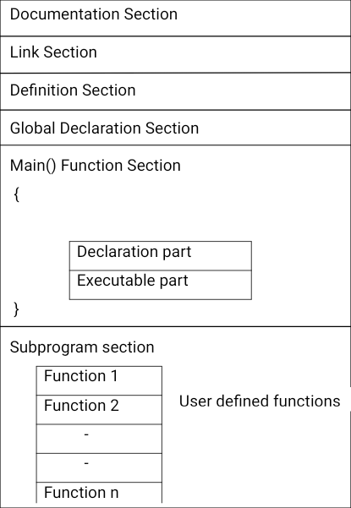

CONSTANTS, VARIABLES AND DATA TYPES:
I. Introduction:
- The programming language is designed to help process certain kinds of data consisting of numbers, characters and strings and provide useful output known as information.
CHARACTER SET:
The characters in C are following categories:
- letters
- digits
- special characters
- White spaces.

1. Letters:
Uppercase A…Z
Lowercase a….z
2. Digits:
All decimal digits 0….9
3. Special characters:
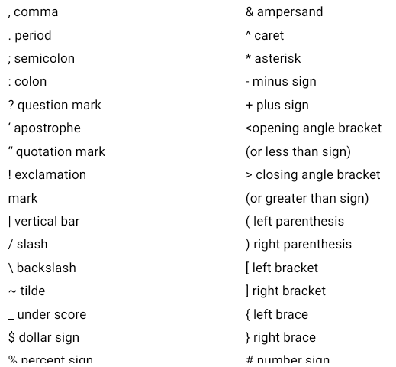

4. White spaces:
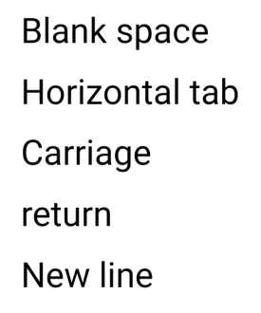

5. Trigraph characters:
- To provide a way to enter certain characters that is not available on some keyboards.
- Each trigraph sequence consists of three characters (two question marks followed by another character)

Trigraph sequence | Translation
??= | # number sign
??( | [ left bracket
??) | ] right bracket
??< | { left brace
??> | } right brace
??! | | vertical bar
??/ | \ back slash
??/ | ^ caret
??- | ~ tilde

C TOKENS:
- Smallest individual unit of a program is called tokens.
- Individual words and punctuation marks are called tokens.
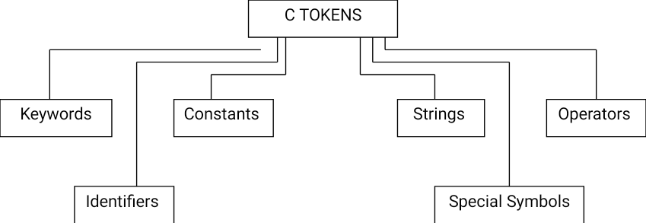

CONSTANTS:
- Constants in C refer to fixed values that do not change during the execution of a program.
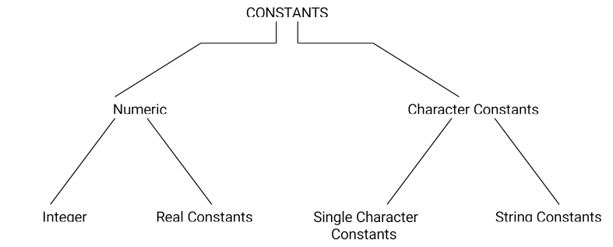

- Integer constants:
  - An integer constant refers to a sequence of digits.
  - There are three types of integers, namely, decimal integer, octal integer and hexadecimal integer.
    - Decimal integer:
      - It consists of a set of digits, 0 through 9, preceded by an optional – and + sign.
      - Example:
123 -321 0 47657 +787
- Spaces, commas, and non-digit characters are not permitted between digits.
- Example:
15 750 20,000 $1000
  - Octal integer:
    - It consists of any combination of digits from the set 0 through 7, with a leading 0.
    - Example:
078 0 0887 0765
      - Hexadecimal integer:
        - Sequences of digits preceded by 0x or 0X.
        - It includes alphabets A through F or a through f.
        - A letter A through F represent the numbers 10 through 15..
        - Example:
0X3 0x9F 0Xbcd
          - Real integers:
            - Integer numbers are inadequate to represent quantities are represented by numbers containing fractional parts like 17.789.
            - A real numbers expressed in exponent notation. Ex: 215e2.
            - The general form is:
Mantissa e Exponent Value

- The mantissa is either real number expressed in decimal notation or an integer.
- The exponent is an integer number with an optional plus or minus sign.
  - Single character constants:
    - It contains a single character enclosed within a pair of single quote marks.
    - Example: ‘5’ ‘X’ ‘;’
- String constants:
  - It is a sequence of characters enclosed in double quotes.

  - The characters may be letters, numbers, special characters and blank space.
  - Example: “hello” “1998” 6+8”
- Backslash character constants:
- It is used in output functions.
- For example, the symbol ‘\n’ stands for newline character.
Constant | Meaning
‘\a’ | audible alert(bell)
‘\b’ | back space
‘\f’ | form feed
‘\n’ | newline
‘\r’ | carriage return
‘\t’ | horizontal tab
‘\v’ | vertical tab
‘\’’ | single quote
‘\”’ | double quote
‘\? | question mark
‘\\’ | backslash
‘\0’ | null

KEYWORDS AND IDENTIFIERS:
Keywords:
- C word is classified as either keyword or an identifier.
- All keywords have fixed meanings cannot be changed.
- Keywords serve as building blocks for program statements.
- All keywords must be written in lower case.
ANSI C Keywords:

auto | double | int | struct
break | else | long | switch
case | enum | register | typedef
char | extern | return | union
const | float | short | unsigned
continue | for | signed | void
default | goto | sizeof | volatile
do | if | static | while

Identifiers:
- It refers to the names of variables, functions and arrays.
- These are user-defined names and consist of a sequence of letters and digits, with a letter as a first character.
- Both uppercase and lowercase letters are permitted, although lowercase letters are commonly used.
- The underscore character is also permitted in identifiers.
- It is usually used as a link between two words in long identifiers.
VARIABLES:
  - It is a data name used to store a data value.
  - A variable take different values at different times during the execution f a program.
  - Variable names consist of letters, digits, and the underscore character.
  - Example:
Average height T_raise ph_value x1 sum1
DATA TYPES:
Storage representations and machine instructions to handle constants differ from machine to machine.
- Three classes of data types:
- primary data types
- derived data types
- User-defined data types.
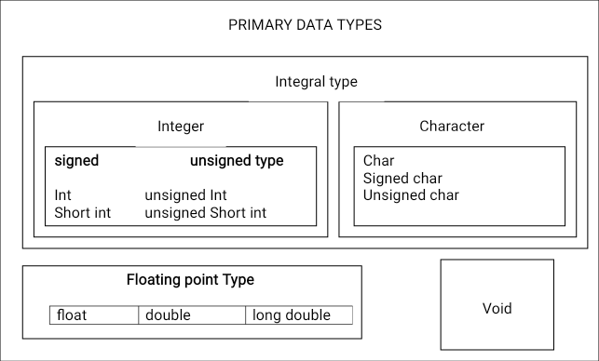

  - Size and range of basic data types on 16-bit machines

Data type | Range of value
Char | -128 to 127
Int | -32,768 to 32,767
F;oat | 3.4e-38 to 3.4e+e38
Double | 1.7e-308 to 1.7e+308
- Integer types:
  - Integers are whole numbers with a range of values supported by a particular machine.
  - Range of values is -32,768 to 32,767
  - C has three classes of integer storage namely
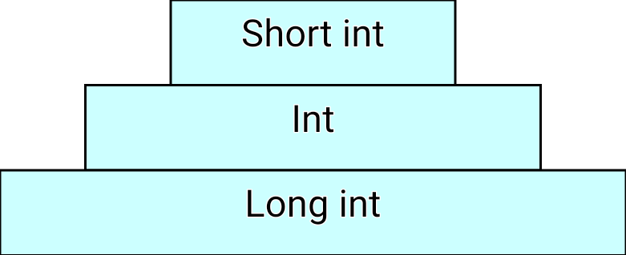

- Floating point types
- Floating point or real numbers are stored in 32 bits with 6 digits of precision
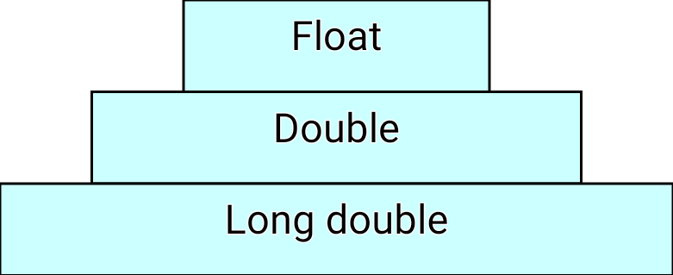
- It is defined by the keyword float. If the float number is not sufficient the type double is used to define the number.

- Void types
- It has no values
- It is used to specify the type of functions.
- The type of a function is said to be void when it does not return any value to the calling function.
  - Character types
    - A single character can be defined as a character (char) type data. It is usually stored in 8-bit of internal storage.
DECLARATION OF VARIABLES
      - The variable names are must declare them to the compiler. the declaration of variables must be done before they are used in the program.
      - Declaration does two things:
- It tells the compiler what the variable name is.
- It specifies what type of data the variable will hold.

  - primary type declaration
    - A variable can be used to store a value of any data type. the name is has nothing to do with its type.
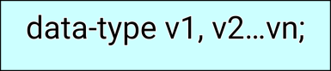
    - syntax

Where v1, v2,..vn are the names of variables. variables are separated by commas.
- A declaration statement must be end with a semicolon.
examples:
int s;
float r;
char i;

- data types and their keywords

data type | keyword equivalent
character | char
unsigned character | unsigned char
signed character | signed char
signed integer | signed int(or int)
signed short integer | signed short int
signed long integer | signed long int  or long int or int
unsigned integer | unsigned int
unsigned short integer | unsigned short int
unsigned long integer | unsigned long int
floating point | float
double-precision floating point | double
extended double-precision floating point | long double

- main() is the beginning of the program.
- The opening brace {signals the execution of the program.

- Declaration of variables is usually done immediately after the opening brace of the program.
- The variable can also be declared outside the main function.
- When an adjective (qualifier) short, long, or unsigned is used without a basic data type specifier, c compilers treat the data type as an int.
  - User-defined type declaration
- There are two types of user-defined data types.
- type definition
- enumerated data type
Type Definition
  - type definition that allows users to define an identifier that would represent an existing data type.
  - The user-defined data type identifier can later be used to declare variables.
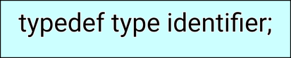
  - syntax

  - Where type refers to an existing data type, identifier refers to the new name given to the data type.
  - The existing data type may belong to any class of type, including the user-defined ones.
  - Examples:
typedef int units;
typedef float marks;
the units and marks can be later used to declare variables as
units batch1, batch2;
marks name1 [20], name2[20];
- Here, batch1, batch2 are declared as int and name1[20],name2[20] are declared as floating point array variables.
- The advantage of typedef is that we can create meaningful data type names for increasing the readability of the program.

Enumerated Data Type
Syntax
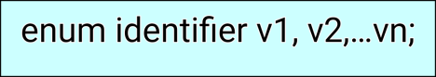

- Where “identifier” is a user-defined enumerated data type which can be used to declare variables that can have one of the values enclosed within the braces known as enumeration constant.

- After this definition, we can declare variables to be of this “new” type as
enum identifier v1, v2, , …vn;
- The enumerated variables v1, v2, vn can only have one of the values value1, value2…valuen. the assignment statement is
v1=value6;
v2=value4;
- Example:
enum day {monday, tuesday,…sunday}
enum day week_start, week_end;
week_start=monday;
week_end=friday;
- The compiler automatically assigns integer values beginning with 0 to all the enumeration constants.
- The automatic assignments can be overridden by assigning values explicitly to the enumeration constants.
- Example:
enum day {monday = 1, tuesday,…sunday}
- Here, the constant monday is assigned the value of 1. the remaining constants are assigned values that increase successively by 1.

DECLARATION OF STORAGE CLASS
STORAGE CLASS:
  - It provides information about their location and visibility.
  - The storage class decides the portion of the program within which the variables are recognized.
  - Example:
int m ;
main()
{
int I;
float balance;
…..
…..
function1();
}
function1()
{
int I;
float sum;
…
…..
}

Global Variable
    - The global variables are used in all the functions in the program.
    - It needs not to be declared in other functions.
    - Global variable is also known as external variable.
Local Variable
    - They are declared inside the function.
- visible and meaningful only inside the functions in which they are declared
- The storage class is added to a variable declaration as
auto int count;
register char ch;
static int x;
Storage class | Meaning
Auto | Local variable known only to the function in which it is declared. Default is auto.
Static | Local variable which exists and returns its value even after the control is transferred to the calling function.
Extern | Global variable known to all functions in the file
Register | Local variable which is stored in the register.
extern long total;

ASSIGNING VALUES TO VARIABLES:
- The values are assigned to the variables in two ways.
  - assignment statement
  - reading data from keyboard
    - Assignment statement
Values can be assigned to variables using the assignment operator =
Syntax:
Variable_name=constant;

Example:
a=86;
b=60.50;
- C permits multiple assignment statement in one line.
- Example
a=86; b=60.50;

- An assignment statement implies that the value of the variable on the left to the “equal sign” is set equal to the value of the expression on the right.
Example:
sum=sum+1;
- It is also possible to assign a value to a variable at the time the variable is declared. this takes the following form
Syntax:
datatype variable_name=value;
Example:
int a=86;
Reading data from keyboard
  - Another way of giving values to variables is to input data through keyboard using the scanf function.
Syntax:
scanf(“control string”,&arg1,&arg2,…,&argn);
- Where the “control string” contains the format of data being received.
- arg1,arg2,…argn specifies variable names declared in the program.
- The ampersand symbol & before each variable name is an operator that specifies the variable name’s address.
DEFINING SYMBOLIC CONSTANTS

We often use certain constants in a program. These constants may appear repeatedly in a number of places in the program.
- We face two problems in the subsequent use of such programs.
  - problem in modification of the program
  - Problem in understanding the program.
Modifiability:
    - To change the value of “pi” from 3.142 to 3.14159 to improve the accuracy of calculations.
    - To search throughout the program and explicitly change the value of the constant.
Understandability
- When a numeric value appears in a program, its use is not always clear, When the same value means different things in different places.
A constants is defined as follows:


Example:
#define STRENGTH 100
#define PASS_MARK 50
- Symbolic names are sometimes called constant identifiers.
- The symbolic constants (not variables), they do not appear in declarations.
- The following rules for define a symbolic constants:
- Symbolic names have same form as variables.
- No blank space between the pound sign ‘#’ and the word define is permitted.
- ‘#’ must be the first character in the line.
- A blank space is required between #define and symbolic name and between the symbolic name and the constant.
- #define statements must not end with a semicolon.
- After definition, the symbolic name should not be assigned any other value within the program by using an assignment statement. For example, STRENGTH=100; is illegal.
- Symbolic names are not declared for data types. Its data depends on the type constant.
- #define statements may appear anywhere in the program but it is referenced in the program.

OPERATORS AND EXPRESSIONS:
INTRODUCTION
  - An operator is a symbol that tells the computer to perform certain mathematical or logical manipulations.
  - Operators are used in programs to manipulate data and variables.
  - The operators are part of mathematical of logical expressions.
- C operators can be classified into a number of Categories. They are
- arithmetic operators
- relational operators
- logical operators
- assignment operators
- increment and decrement operators
- conditional operators
- bitwise operators and
- special operators

ARITHMETIC OPERATORS
  - The arithmetic operators are used to perform the arithmetic operations in the program.
  - The operators are as
operator | meaning
+ | addition
- | subtraction
* | multiplication
/ | division
% | modulo division

- Integer division truncates any fractional part.
- The modulo division operation produces the remainder of an integer division.
Integer arithmetic
- When both the operands in a single arithmetic expression are integer, the expression is called an integer expression, and the operation is called integer arithmetic.
- The integer arithmetic yields an integer values.

Example
main()
{
int a,b,c;
a=82;
b=86;
c=a+b;
printf(“\nthe value of c is:%d”,c);
}
Real arithmetic
- An arithmetic operation involving only real operands is called real arithmetic.
- A real operand may be either in decimal or exponential notation.
Example
main()
{
float a,b,c;
a=82;
b=86;
c=a+b;
printf(“\nthe value of c is:%d”,c);
}

Mixed-mode arithmetic
- When one of the operands is real and the other is integer, the expression is called a mixed-mode arithmetic expression.
main()
{
int a;
float b,c;
a=82;
b=86;
c=a+b;
printf (“\n the value of c is: %d”, c);
}

RELATIONAL OPERATORS
- The relational operators are used to compare two quantities and depending on their relation, take certain decisions.

- An expression containing a relational operator is called as relational expression.
- The value of an expression is either one or zero.
- The relational expression contain only one relational operator
- C supports six relational operators. The operators are

operator | meaning
< | is less than
<= | is less than or equal to
> | is greater than
>= | is greater than or equal to
== | is equal to
!= | is not equal to

Syntax:
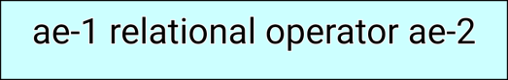

- Where ae-1 and ae-2 are arithmetic expressions, which may be simple constants, variables or combination of them.
- Example
82<=86
a+b<a-b
Relation operator complements
The six relational operators, each one is a complement of another operator.

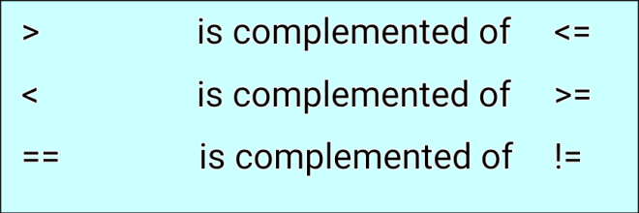

LOGICAL OPERATORS
- The logical operators are used to test more than one condition and make decisions. the logical expression is also known as compound expression.
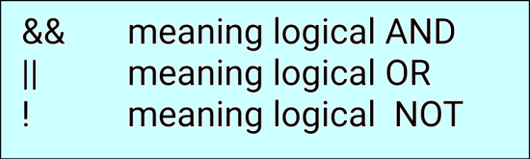

Truth table
op-1 | op-2 | value of the expression
 |  | op-1 && op-2 | op-1 || op-2
non-zero | non-zero | 1 | 1
non-zero | 0 | 0 | 1
0 | non-zero | 0 | 1
0 | 0 | 0 | 0

ASSIGNMENT OPERATORS
Assignment operators are used to assign the result of an expression to a variable. the operator is “=”
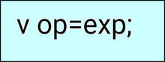
Syntax

- Where v is a variable, exp is an expression and op is a c binary arithmetic operator.
- The operator “op=” is known as the shorthand assignment operator.
- The assignment statement
v op=exp;
is equivalent to
v = v op (exp);
- The shorthand assignment operator has three advantages:
- what appears on the left-hand side need not be repeated and therefore it becomes easier to write
- the statement is more concise and easier to read.
- the statement is more efficient.
  - Example
s+=1;
is equivalent to
s=s+1;

INCREMENT AND DECREMENT OPERATORS
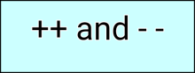
- C allows two very useful operators not generally found in other languages. these are the increment and decrement operators:

- The operator ++ adds 1 to the operand, while – subtracts 1.

Prefix operator
A prefix operator first adds 1 to the operand and then the result is assigned to the variable on left.

Example
++s=r;
is equivalent to
s=s+1;
s=r;
Postfix operator
- A postfix operator first assigns the value to the variable on left and then increments the operand.
Example
s++=r;
is equivalent to
s=r;
s=s+1;
CONDITIONAL OPERATORS
A ternary operator pair “?:” is used to construct conditional expression.
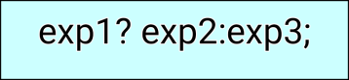
Syntax

- Where exp1, exp2, exp3 are expressions.
- The exp1 is evaluated first. If exp1 is true, then the expression exp2 is evaluated and becomes the value of the expression.
- If exp1 is false, exp3 is evaluated and its value becomes the value of the expression. only one expressions (either exp2 or exp3) is evaluated.
Example
a=6;
b=8;
x= (a>b)? a: b;

SPECIAL OPERATORS
C supports some special operators these operators are
  - comma operator
  - size of operator

  - pointer operators (& and *) and
  - Member selection operators (. and ->)
1. The comma operator:
The comma operator can be used to link the related expressions together.

    - Comma-linked lists of expressions are evaluated left to right and the value of right-most expression is the value of the combined expression.
    - The comma operator has the lowest precedence of all operators, the parentheses are necessary.
Example
s=(x=10,y=20,x+y);
- Here, first assign the value 10 to x, then assign 20 to y, and finally assign 30 to value.
2. The sizeof operator
The sizeof is a compile time operator and, when used with an operand, it returns the number of bytes the operand occupies.
- The may be a variable, a constant or a datatype.
Example
m=sizeof (sum);
s=sizeof (long int);
k=sizeof (234);

ARITHMETIC EXPRESSIONS
- An expression is a combination of variables, constants, and operators arranged as per the syntax of the language.
- C can handle complex mathematical expressions.
Expressions
Algebraic expression | C expression
axb-c | a*b-c
(a+b) (r+s) | (a+b) * (r+s)
6x²+6x+6 | 6 * x * x + 6 * x + 6

EVALUATION OF EXPRESSIONS
The expressions are evaluated using an assignment statement.

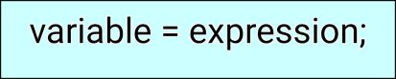
Syntax

- Where variable is any valid c variable name.
- When the statement is encountered, the expression is evaluated first and the result then replaces the previous value of the variable on the left-hand side.

- All the variables used in the expression must be assigned values before evaluating is attempted.

Example:
s=a * b + c;
r=a – b / c;
k=x / y * z;
- The blank space around an operator is optional and adds only to improve readability.
- When the variables are used in the expression, it must be defined before they are used.
PRECEDENCE OF ARITHMETIC OPERATORS
- An arithmetic expression without parenthesis will be evaluated from left to right using the rules of precedence of operators.
- There are two distinct priority levels of arithmetic operators in c.
    - high priority * /%
    - low priority +-
- The basic evaluation procedure includes “two” left-to-right passes through the expression.
- During the first pass the high priority operators are applied as they are encountered.
- During the second pass, the low priority operators are applied as they are encountered.
- Whenever parentheses are used, the expressions within parentheses assume highest priority.

Example
s=6-8/2+6*2-1
First pass
step1: s=6-4+6*2-1
step2: s=6-4+12-1
Second pass
step3: s=2+12-1
step4: s=14-1
step5: s=13

TYPE CONVERSIONS IN EXPRESSIONS:
Implicit Type Conversion
- C automatically converts any intermediate values to the proper type.
- The expression can be evaluated without loosing any significance.
- This automatic conversion is known as implicit type conversion.
- If the operands are of different types, the “lower” type is automatically converted to the “higher” type before the operation proceeds.

Explicit conversion
The process of local conversion is known as explicit conversion or casting a value.

Syntax
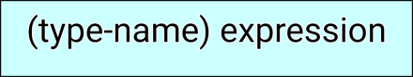

Where type-name is one of the standard c data type. The expression may be a constant, variable of an expression.

OPERATOR PRECEDENCE AND ASSOCIATIVITY
- Each operator in c has a precedence associated with it.
- This precedence is used to determine how an expression involving more than one operator is evaluated.
- There are distinct levels of precedence and operator may belong to one these levels.
- The operator at the higher level of precedence is evaluated first.
- The operator of the same precedence is evaluated either from “left to right” or from “right to left”. Depending on the level.
- This is known as the associativity property of an operator.

Rules of precedence and associativity
- Precedence rules decides the order in which different operators are applied.
- Associativity rule decides the order in which multiple occurrences of the same level operator are applied.

MATHEMATICAL FUNCTIONS
- Mathematical functions are frequently used in analysis of real-life problems.
- Most of the c compilers support these basic math functions.
- Some functions are return a data item to their access point;
- Others indicate whether a condition is true or false by returning a 1 or a 0;
- Others carry out specific operations on data items but do not return anything

MANAGING INPUT AND OUTPUT OPERATIONS

Introduction
- Reading, processing, and writing of data are the three essential functions of computer program.
- All input/output operations are carried out through function calls such as printf and scanf.
- There exist several functions that have more or less become standard for input and output operations in c.
- These functions are collectively known as the standard i/o library.

READING A CHARACTER
- All input/output operations is reading a character from the “standard input” unit and writing it to the “standard output” unit.
- Reading a single character can be done by using the function getchar.
Syntax
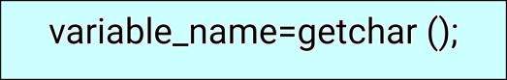

- Where variable_name is a valid c name that has been declared as char data type.
- When the statement is executed, the computer waits until a key is pressed and then assign this character as a value to getchar function.
- Getchar is used on the right-hand side of an assignment statement, the character value of getchar() is turn assigned to the variable name on the left.
Example
char s;
s=getchar ();

WRITING A CHARACTER
- The function putchar is used for writing character one at a time to the terminal.
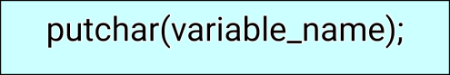
Syntax

- Where variable_name is a type char variable containing a character.

- This statement displays the character contained in the variable_name at the terminal.

Example:
char s;
s=’r’;
putchar(s);

FORMATTED INPUT DECISION MAKING AND BRANCHING
- Formatted input refers to input data that has been arranged in a particular format.
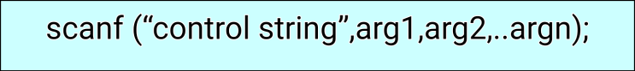
Syntax for Scanf

- The control string specifies the field format in which the data is to be entered and the arguments arg1, arg2,…,argn specify the address of locations where the data is stored.
- Commas separate control string and arguments. It may include
- field (or format) specifications, consisting of the conversion character %, a data type character, and an optional number, specifying the field width.
- blanks, tabs, or newlines.
- blanks, tabs and newlines are ignored.
- The data type character indicates the type of data that is to be assigned to the variables associated with the corresponding argument.
- The field width specifier is optional.
Inputting Integer Numbers
- The field specification for reading an integer number is:
%wd
- The percent sign (%) indicates that a conversion specification follows.
- w is an integer number that specifies the field width of the number to be read and d known as data type character indicates that the number to be read is in integer mode.
Example
int num1, num2;
scanf(“%6d %4d”,&num1, &num2);
Inputting Real Numbers
- The field width of real numbers is not to be specified and therefore scanf reads real numbers using the simple specification %f for both the notations, namely, decimal point notation and exponential notation.

Example
scanf (“%f %f %f”, &x, &y, &z);

Inputting Character Strings
- A scanf function can input strings containing more than one character.
- The following specifications for reading character strings:
%ws or %wc
- The corresponding arguments should be a pointer to a character array.
- however, %c may be used to read a single character when the argument is a pointer to a char variable.

Example
char name[20];
scanf(“%15s”, name);

Reading Mixed Data Type
- we can use one scanf statement to input a data line containing mixed mode data.
- in such cases, should be exercised to ensure that the input data items match the control specifications in order and type.
- when an attempt is made to read an item that does not match the type expected, the scanf function does not read any further and immediately returns the value read.
Example
int count;
char code;
float ratio;
char name[20];
scanf(“%d %c %f %s”,&count, &code, &ratio, name);

Detection of Errors in Input:
- When a scanf functions completes reading its list, it returns the value of number of items that are successfully read.
- This value can be used to test whether any errors occurred in reading the input.

Commonly Used scanf Format Codes
Code meaning
%c read a single character

%d read a decimal integer
%e read a floating point value
%f read floating point value
%g read floating value
%h read a short integer
%i read a decimal, hexadecimal or octal integer
%o read an octal integer
%s read a string
%u read an unsigned decimal integer
%x read a hexadecimal integer
%[..] read a string of word(s)

Points To Remember While Using Scanf
- All function arguments, except the control string, must be pointers to variables.
- Format specifications contained in the control string should match the arguments in order.
- Input data items must be separated by spaces and must match the variables receiving the input in the same order.
- Any read data items in a time will be considered as part of the data input line to the next scanf call.
- When the field width specifier w is used, it should be large enough to contain the input data size.

FORMATTED OUTPUT:
- printf function is used for printing captions and numerical results.
- They are understandable and are in an easy-to-use form.
- The printf statement provides certain features that can be effectively exploited to control the alignment and spacing of print-outs on the terminals.
Syntax
printf(“control string”, arg1,arg2,…argn);
Control string consists of 3 types
  - Characters that will be printed on the screen as they appear.
  - Format specifications that define the output format for display of each item.
  - Escape sequence characters such as \n, \t, and \b.
- The control string indicates how many arguments follow and what their types are.
- The arguments arg1, arg2, …, argn are the variables whose values are formatted and printed according to the specifications of the control string.
- The arguments should match in number, order and type with the format specifications.

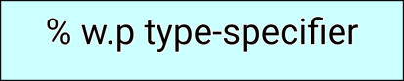
Syntax for Format Specification

- where, w is an integer number that specifies the total number of columns for the output value.
- p -> another integer number that specifies the number of digits to the right of the decimal point or the number of character to be printed from a string. both w and p are optional.
Output of Integer Numbers
- The format specification for printing an integer number is
%wd
- Where w specifies the minimum field width for the output.
- d specifies that the value to be printed is an integer.
- The number is written right-justified in the given field width.
Example
int s=8286;
printf(“%6d”,s);
printf(“%2d”,s);
Output of Real Numbers
- The output of a real number may be displayed in decimal notation.
Syntax for Format Specification
% w.p f
- Where w indicates the minimum number of positions that are to be used for the display of the values.
- p indicates the number of digits to be displays after the decimal point.
- The value, when displayed, is rounded to p decimal places and printed right-justified in the field of w columns.
- The decimal precision is 6 decimal places.
- The negative numbers will be printed with the minus sign.
- we can also display a real number in exponential notation by using the specification
%w.p e
- Some systems also support a special field specification character that lets the user define the field specification character that lets the user define the field size at run time.
Syntax
printf(“%*.*”, Width, precision)
- The field width and the precision are given as arguments which will supply the values for w and p.

Example
float s;
s=60.8286;
printf(“%7.4f”,s);
printf(“%7.2f”,s);
Printing of a Single Character:
- A single character can be displayed in a desired position.
Syntax: %wc
- The character will be displayed right-justified in the field of w columns.
- We can make the display left-justified by placing a minus sign before the integer w.
- The default for w is 1.
Example
char s=’r’;
printf(“%3c”,s);
Printing of Stings
- The format specification for outputting strings is similar to that of real numbers.
Syntax
%w.ps
- Where w specifies the field width for display and p instructs that only the first p characters of the string are to be displayed.
- The display is right-justified.
Example
char str[20]=”c program”;
printf(“%20s”,str);
printf(“%20.2s”,name);

Mixed Data Output
- It is permitted to mix data types in one printf statement.
- printf uses its control string to decide how many variables to be printed and what their types are.
Commonly Used printf Format Codes
code meaning
%c print a single character
%d print a decimal integer
%e print a floating point value
%f print floating point value
%g print floating value
%h print a short integer

%i print a decimal, hexadecimal or octal integer
%o print an octal integer
%s print a string
%u print an unsigned decimal integer
%x print a hexadecimal integer

Enhancing the Readability of Output
- Outputs are used as information for analyzing certain relationship between variables and for making decisions.
- Therefore the correctness and clarity of outputs are of utmost importance.
- The clarity depends on the way the output is presented.
- The steps are used to improve the clarity of the outputs.
- Provide enough blank space between two numbers
- Introduce appropriate headings and variables names in the output.
- Print special messages whenever a peculiar condition occurs in the output.
- Introduce blank lines between the important sections of the output.

